**~By LewisFenrir**®

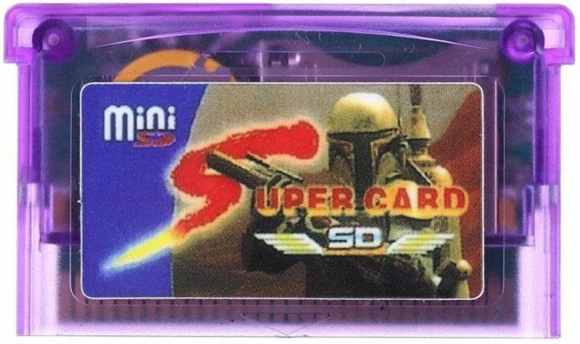

**INSTRUCTIONS FOR THE PROPER FUNCTIONING OF SUPERCARD SD/MINI SD AND TIPS**

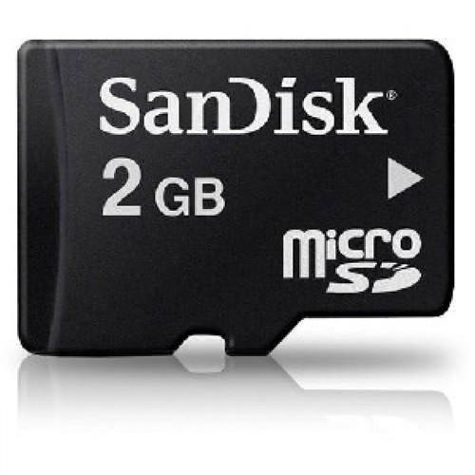

**\* You must have a good quality micro SD card up to 2gb of memory and it must not be the SDHC type.**

**\*Backup your micro SD files and format it with its allocation unit size to 64 kilobytes (not 32) and its file system to FAT (not FAT32 or exFAT). Pass your files back to your micro SD.**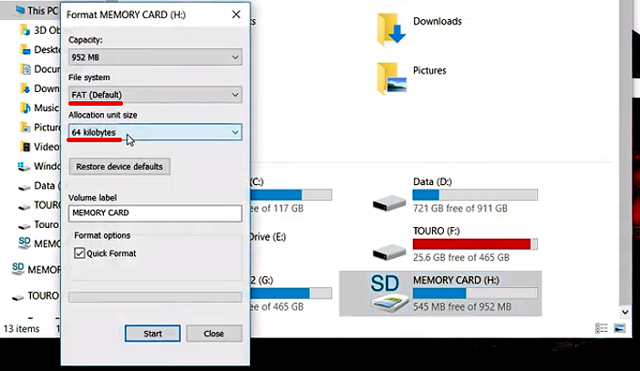

**\* GBA roms can’t be simply put into the micro SD, first you have to convert them with the Supercard’s PC software, converting them to your SD in that process.**

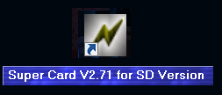

**\* Always download european roms (they have bri’ish english included) preferably, if an european rom doesn’t work, download an american one. There are european games in which the multiplayer doesn’t work when linked to a american game (like Shining Soul II), so just download an american one or ask your friend to download an european one.**

**\*Wowroms is a great site for downloading roms.**

**\*It is possible to play multiplayer with Supercard (Supercard linked to original and fake games, to another Supercard or any other GBA flashcart).**



**HOW TO SAVE YOUR GAMES, ROMS OPTIMIZATION, LAGS AND ERRORS FIX, EMULATORS, TIPS AND ETC**

**[01]** - Always run the SC software as Admin.

**[01.3]** - The path of the conversion of the roms on the SC software (on options) must be in the micro SD.

**[01.6] - I’ve made pre-supercard-converted and optimized roms (that all you have to do is to drop them in your SD and play, don't have to do anything) but i can't post the link to them in this guide, so if you want to talk to me about it email me on** [**lewissupercardhero@gmail.com**](mailto:lewissupercardhero@gmail.com)**. All of the programs, emulators, etc which i mentioned in this guide i posted in my Google Drive below. *Programs and etc:** [**https://drive.google.com/drive/folders/1wlUNVHNsCfcO56zalFbbQDwyVwLaS3GR?usp=sharing**](https://drive.google.com/drive/folders/1wlUNVHNsCfcO56zalFbbQDwyVwLaS3GR?usp=sharing)

**[02]** - **HOW TO SAVE YOUR GAMES**

**\*\*Save files (.sav and .sci) must always be in the same paste of its roms\*\*** *I strongly recommend you to backup your save files to your pc once in a while.*

**Save via QPC (Quick Power Circle) ->**  (1) - Save normally in the game and quickly turn off and back on your GBA (*If you’re playing in the DS, reboot in GBA mode by holding the right key, since it won’t work in DS mode*)

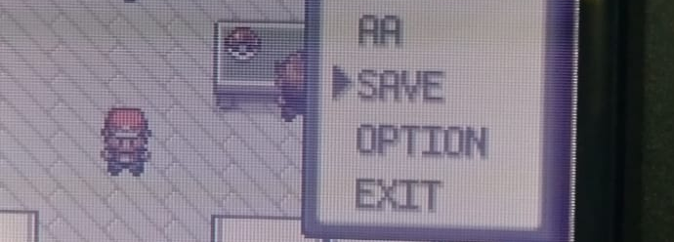

(2) - Go to the "SAVER" tab, search for the name of your game, click A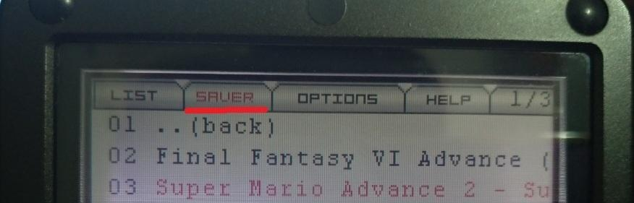

(3) - It will appear "Do you save to SD?" (if it doesn’t show anything try again in the other file with the same name) and click A again. Done!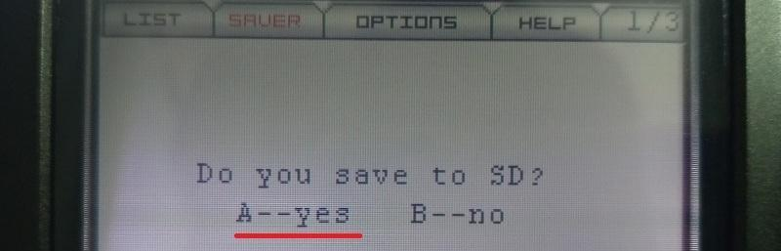

(4) You load your saves in the very game. **\*Never save Pokémon games in this mode.**

*In case you have problems with this mode, check item **[04]**.  *The saves are created in the .sav files, so you can back them up to your PC. This mode utilizes the Supercard’s battery (CR2025) , so in the future its charge will cease, and if you save by this mode again when the battery is dead your save may be deleted, that’s why it’s important to back up the saves once in a while. I recommend saving via **SC Normal Save (L+R+A+SELECT)** because it doesn’t use the battery.

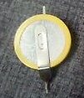

*The battery is used only for the QPC mode, Supercard doesn’t have support for the RTC function (Real Time Clock), however, there are RTC patches for Pokémon roms.

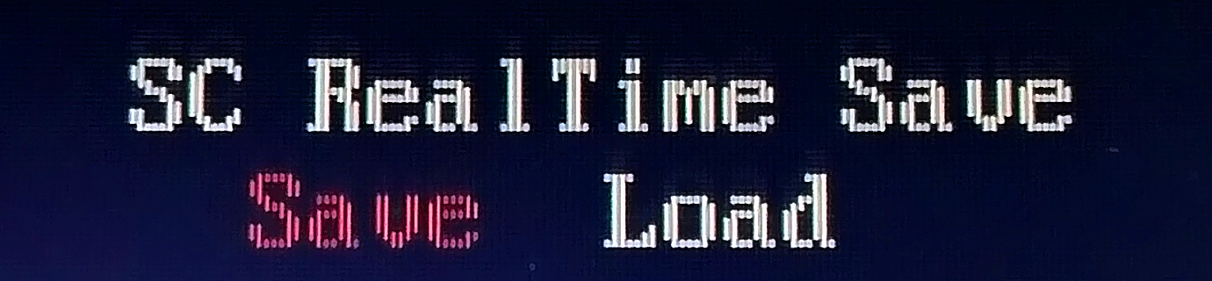

**Save via SC Real Time Save (save states):**

Save at any moment by holding **L+R+B+SELECT,** A in “Save” and A in “Yes”. Load your save at any moment doing that **same combo** as when you save, click A in “Load” and A in “Yes”.

**\*Don’t always save Pokémon games by this mode, i recommend you to save via SC Normal Save at least a few times during the game and at least once before beating Elite 4, otherwise the game will delete your save after you beat it, and it’s the same case for Visual Boy Advance or any other GBA emulator.**  *The save is created in the.sci file and it doesn’t use the battery.

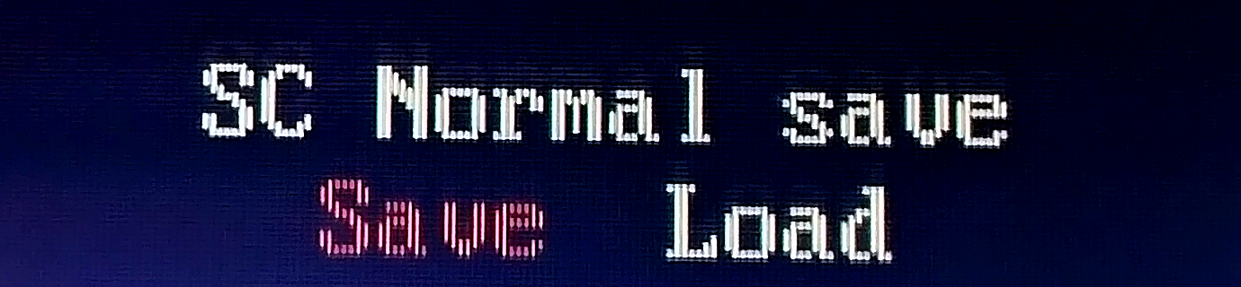

**Save via SC Normal Save:**

Save in the game, hold **L+R+A+SELECT**, click A in “Save” and A again in “Yes”. To load your save, start the game and right after do that same combination as when you save, click A in “Load” and A in “Yes”.

*The save is also stored in the .sav file and doesn’t use the battery.

**[03]** - **ROM optimization methods**  Methods for making some games faster, for fixing bugs, lags and playing some games that can’t be played. These methods are used before converting the roms in the SC software, roms converted by it can’t be modified anymore, except for Method 3.

*You can use a single method in a rom or two methods, for example: Gba Tool and Fastrestart afterwards or Gba Tool and Prefetch Patcher respectively in these orders only, but you can’t use Fastrestart and Prefetch Patcher (or vice versa) together because one nullifies the other.*

**\*Method 1** **(GBA Tool Advance)** (all save modes work)

*This method is for making roms which don’t save/don’t save properly to get to save properly and it possibly fixes some bugs, but i strongly believe that it doesn’t make roms faster. **\*You MUST do this method in all your Pokémon roms to save them, otherwise you won’t be able to do it.\***

(1) Open **Gbata (GBA Tool Advance)** as admin, click on the ellipsis box and load a rom 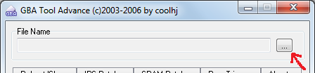

(2)go to SRAM and click on Patch (Some games don’t work in this program because they don’t need it, so proceed to one of the other following methods), now your rom will be the one named **"output-**" before its name. Done!

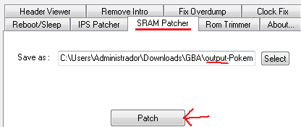

(3) If after this method you can save your rom properly, noice! But if your rom is still slow and has some bugs/glitches, proceed to one of the following methods (with a non converted rom by the SC software).

**\*If you use only this method in a rom, you must mark the boxes “enable save”, “enable saver patch” and “real time save” by clicking twice on the rom(s) in the SC software before converting them (see image below).**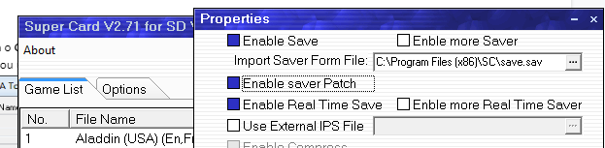

*It is also possible to do IPS patch with Gba Tool.

**\*Method 2 (FASTRESTART)** (only **SC Normal Save** and **QPC** save modes work after this method) ->

*From what I've realized, this program is only for making roms faster and removing some glitches and bugs.

(1) Drag the rom (or multiple roms) onto "**fastrestart.exe**", after the process is finished click ENTER. It will modify your rom(s) and create a .sav file with the same name.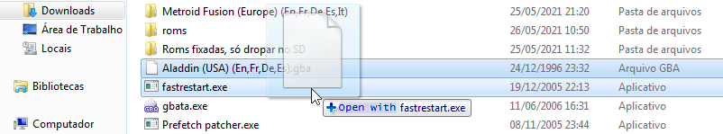

(2) Put only the rom in the SC software, click twice on it and mark ONLY the box "enable saver patch” (however if you used Method 1 before, **mark also the box “enable save”**, otherwise you won’t be able to save your game), click OK

(3) Convert it and put the .sav file from step (1) in the same folder of the rom in the micro SD (if there is already a .sav file of the game in there, delete it and replace it for the one from step (1)). Done!

*After starting a game, holding **L+R+A+SELECT** and getting back to the game may fix some glitches and make it faster.

*It is possible to also mark the “restart" box on step (2) on the SC software, but sometimes (as in Final Fantasy VI) that will only make it slower, in other cases it makes it faster.

**\*Method 3 (PREFETCH PATCHER)** (only **QPC** works after this method)

*from what i’ve analyzed, this method is for making roms which don’t work at all to work, fixing some glitches and making roms faster

(1) Load your rom in the SC software, click on it twice and make sure only the “Enable Save" and "Enable Saver Patch" boxes are marked.

(2) Convert it (by clicking on Out) and drag only the converted rom by the SC software onto "**Prefetchpatcher.exe**" (only one at a time).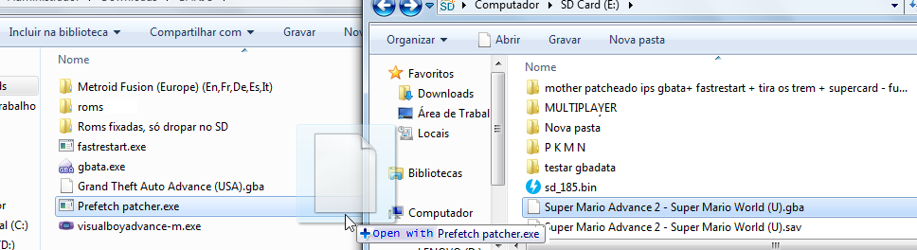

(3) Done.

**FIXING ERRORS **

**[04]** - **QPC doesn’t work/doesn’t work anymore** -> if the **QPC** method isn’t working it is possible that the Supercard’s battery is dead, check it with a multimeter. In this case, theoretically, just replace it with a new one (CR2025 or CR2032 (lasts longer).

If the problem isn’t the battery, maybe your firmware version doesn’t allow QPC to work, I've read that in the version 1.63b of the firmware you are able to save. Link: <http://web.archive.org/web/20070204132548/http://eng.supercard.cn/download/setupsdV255Cen.rar>

*The firmware is the file named "sd_163.bin" inside that RAR file. Put the firmware in the root of your micro SD. To install it, go to the SC menu, go to that file and click A, wait a bit and it will show "Are you sure upgrade?", click A and wait until the process is over, when you’re back to the SC menu screen it will be already installed in your SC.

*If nothing works, there is the **DumpSRAM**, i know almost nothing about it, but this site explains everything: <https://forum.gbadev.org/viewtopic.php?t=12204>

Link for downloading **DumpSRAM**: <http://web.archive.org/web/20160329135932/http://www.watzmanassociates.com/josh/programming/downloads/dumpSRAM-1.2.tar.bz2>

**[05]** - **"fail" in "patch" in the Supercard software** -> In the overwhelming majority of the time this isn’t a problem at all, i’m always converting roms on this software and i’ve never had problems with that.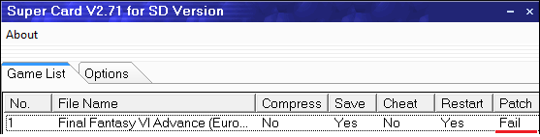

**[06] - Blank screen when running a game/rom loading screen “freezes” when you try to run a game/ -**> You must have a good quality micro SD up to 2gb of memory and it must not be the SDHC type. Back up your micro SD files to your PC, format your SD with its allocation unit size to 64 kilobytes and its file system to FAT (not FAT32 or exFAT) and pass your files back to your micro SD.

**[06.3] - Supercard is not recognized by Game Boy Advance/ Game Boy Advance reads the Supercard as a Game Boy Color game**-> Maybe the pcb of your Supercard doesn’t fully touch the back plastic, it is kinda suspended in the air as in the photo below (pay attention to the blue and red lines)

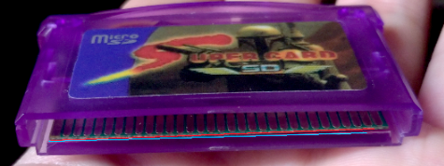

This way the pads are not well recognized by the GBA, so a possible solution is to put a small folded paper in a way that the plastic where is the little blue arrow (photo below) pushes the little paper which also pushes down the misaligned part of the pcb to the back plastic, thus making a better connection with the GBA’s cartridge receiver.

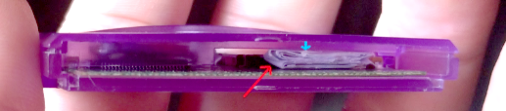

If that doesn’t work, try pushing the SC in the GBA without inserting it all the way (but without removing the paper):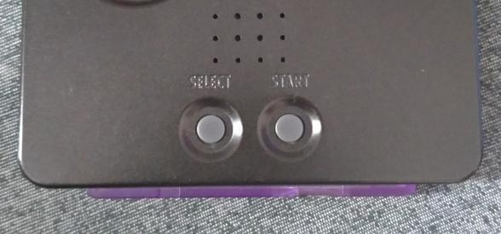

If it doesn’t work in a position, try pulling it out a bit or pushing it in a bit and trying to turn it on until the GBA gets to read it. Try removing and inserting back the micro SD too. If this also doesn’t work, try opening the cartridge and rubbing a clean eraser on the pads (cleaning its remains with toilet paper afterwards), and then you may clean all the pcb with a clean toothbrush and isopropyl alcohol (only the isopropyl one). If nothing works, try polishing the pads with a cotton swab wet with metal polisher and cleaning them with isopropyl alcohol (this also works for game boy and game boy advance cartridges).

**[06.6]** Supercard works on Nintendo DS but not on GBA -> Try step [06] and [06.3]

**[07] - Error "Access violation at address "xxxxxxxx" in module 'SuperCardsd.exe'. Read of address "xxxxxxxx"** -> Don’t forget to always open the SC software as Admin. Try downloading roms from other sites and the american ones of the roms you want (if you downloaded the european ones. If you downloaded american roms, now download and try european roms).

**[08] - "OPEN FILE ERROR" in the Supercard software** -> 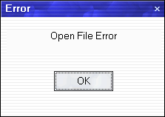

First, check if your micro SD is inserted in your PC, if it is not, insert it and try again. If this doesn’t work, verify if the path of the conversion (in Options) is to your micro SD.

If this error persists:

Create a new paste in the micro SD and convert again these roms to it (changing the path of the conversion). If the error still persists, download european roms. Try downloading roms from multiple sites if the first one doesn’t work..

*You could also rename the .SAV and .SCI files from another game which you won’t play to the same name of the game you want to play and put them in the same paste in your micro SD (However i don’t think this is necessary, the other options will probably fix your problem).

**EMULATORS AND TIPS**

**[09] - ROM HACKS** ->

There is the type of romhack that is the .IPS format (not .GBA), and to make it work you have to patch it with its original GBA rom (for example, Pokémon Fire Red is the original rom of Pokémon Rocket Science.IPS).

In order to make your game playable, put the original rom in the SC software, click twice on it, mark the “Use external IPS file”box, click on the ellipsis box and select the .IPS file and click OK. Then convert (clicking on Out) it to your SD and play. There are rom hacks that don’t work when you do the patch in the SC software, if this happens, try to do the patch in Lunar IPS or Gba Tool Advance.

*However, regarding all Pokémon rom hacks, you must do the method 1 (Gba Tool Advance) in the original roms before the ips patch or anything in order to get to save your roms.

**[09.3]** - Some rom hacks don’t work when you do the IPS patch in the SC software, a possible solution is to do it in the Lunar IPS or in the Gba Tool Advance program. Keep trying, if it doesn’t work in a program, in another it will.

**[10] - Cheats** ->

-Put your game in the SC software and click on it twice

-Mark the “Enable Cheat” box and click OK.

-Click twice on the rom again, click once on any of the itens in the box below “Cheat File”, click on “Add”

-Write what the cheat does in "Description" and put its code in "Data"

-Click OK and OK again, Convert it to your micro SD.

-Run your game and hold L, R, START e A, activate the cheats and click B. Done. Done.

The SC software already has pre-installed cheats on it, but there are few. To put more cheats you will have to put all of them manually.



**[11] - Game Boy/Game Boy Color emulator and how to save**-> The SC has a built-in GBC emulator (Goomba Color alpha 6), you just have to put the roms in your SD and play, don’t need to convert or anything. To save, first save in the game, then hold L+R, click A in "save state", then do the **SC Normal Save** combo and click A in "Save into SD?"

*The Supercard creates .sav files of your gbc games.

*There’s a new and better version of this emulator, it’s Goomba Color 2019. I did a tutorial for it (see below). By the way, I strongly recommend it over its older version because the games run better and faster in it. *There are also NES and Master System emulator for the SC.

**[11.3] - Goomba Color 2019 Tutorial ->**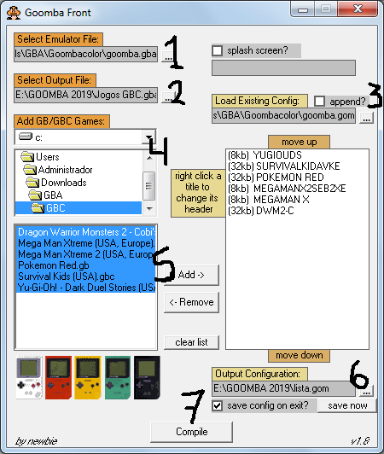

-in number 1, select goomba.gba in the Goomba Color paste

-in number 2, first create a new paste for your gbc games in your micro SD, click on the ellipsis box on number 2 and write a name for the file, go to the paste that you’ve just created and click on save, this will be the file which you will play your games

-in number 3, select goomba.gom in the Goomba Color paste

-in number 4, select a paste in your PC that has your gbc games

-in number 5, click in the first game and hold ctrl+shift+down to select all the games and click Add

-in number 6, write a name for the file and save it in your gbc paste in your SD

-click on "Compile" on number 7. Done!

-To save the games, save in the game, hold L+R, click A in Save State and click A in your game.

**[12] - Compatibility list for Supercard roms:** <http://web.archive.org/web/20060424130043/http://gba.vltava2000.cz/shops/7000/html/SCGBAlist.htm>

Phantasy Star Collection actually works, only its first game (phantasy star I) doesn’t.

**[13] - Backup of the Supercard website which you can download different software and firmware versions for all the versions of the flashcart** In different dates there are different versions. Link: [http://web.archive.org/web/20071101000000*/http://eng.supercard.cn/download.htm](http://web.archive.org/web/20071101000000*/http://eng.supercard.cn/download.htm)

*There’s a program made by the creators of the Supercard that allows you to watch videos in the GBA, but i don’t know anything about it. Link: <http://web.archive.org/web/20070501173041/http://eng.supercard.cn/soft_sd.htm>